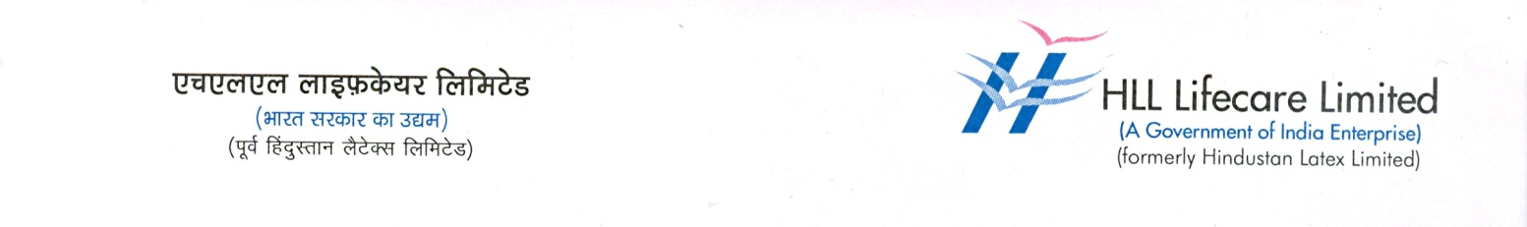

**27 September 2024**

**HLL’s "THINKAL" project wins SKOCH Award**

**for contributions to menstrual hygiene in India**

Thiruvananthapuram: HLL Lifecare Limited, a public sector enterprise under the Ministry of Health and Family Welfare, Government of India, has won the prestigious SKOCH Award for its "THINKAL" project, which focuses on the distribution and awareness of eco-friendly menstrual cups (M-Cups) across India. The THINKAL – Awareness creation and distribution of menstrual cups initiative is a key project of HLL Management Academy (HMA), HLL’s education and social development wing.

V. Kuttappan Pillai, Senior Vice President i/c (T&O)-HLL, received the award from Sameer Kochhar Chairman, SKOCH Group at a function held at Silver Oak Hall, India Habitat Centre, Lodhi Road New Delhi. Shamnad Shamsudeen (Deputy Vice President) and Dr Krishna SH. (Deputy Project Manager), HMA were present during the occasion.

The SKOCH Award, one of India’s most respected accolades, recognises notable contributions in governance, finance, and social development. The award committee acknowledged the THINKAL project’s innovative approach in addressing women’s health and environmental sustainability.

The M-Cup is a menstrual hygiene product made from medical-grade silicone, designed to be reusable and environmentally friendly. The THINKAL project was initially developed in response to the sanitary napkin disposal issues faced during the Kerala floods. By promoting the use of M-Cups, HLL provided a sustainable solution and initiated a long-term shift toward eco-friendly menstrual practices. The pilot project successfully reached 5,000 women in Alappuzha, Kerala, with the support from Coal India Limited’s CSR funds.

A follow-up study showed a 91.5% acceptance rate for M-Cups among users, which led HLL to expand the project. To date, the THINKAL project has reached over 700,000 women across India, including those in rural and tribal communities. It has contributed to reducing sanitary waste and CO2 emissions while empowering women to manage their menstrual health more effectively.

Currently, the THINKAL project is being implemented in seven states and one union territory, including Kerala, Tamil Nadu, Karnataka, Maharashtra, Gujarat, Jharkhand, Telangana, and Lakshadweep. The initiative also led to the creation of India’s first two sanitary napkin-free villages—Kumbalangy Grama Panchayat in Ernakulam and Kallikkad Grama Panchayat in Trivandrum. The use of 5,00,000 M-Cups over 5 years is expected to result in a cost saving of Rs. 1,000 Lakhs, reduce 10,000 tonnes of menstrual waste, and lower CO2 emissions by 13,250 tonnes.

**Photo Caption :** V. Kuttappan Pillai, Senior Vice President i/c (T&O)-HLL, receiving the award from Sameer Kochhar Chairman, SKOCH Group at a function held at Silver Oak Hall, India Habitat Centre, Lodhi Road New Delhi. Shamnad Shamsudeen (Deputy Vice President) and Dr Krishna S H. (Deputy Project Manager), HMA are also seen.

