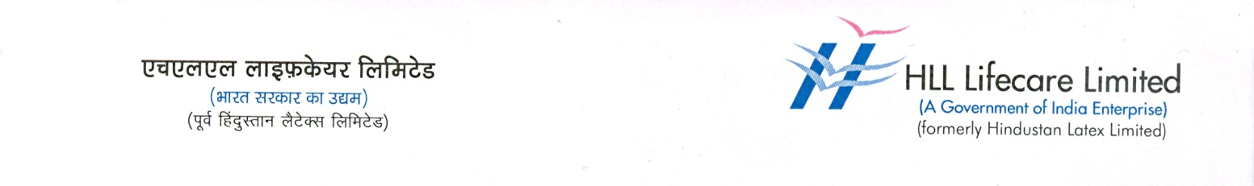

**PRESS RELEASE**

**AMRIT Pharmacy Chain: A first-of-its-kind Retail Revolution in healthcare entering into its 10th Year of excellence**

**Benefits over 554 Lakh patients to date**

**Signs MoU with SECL for new hospital Pharmacies**

Thiruvananthapuram, 15 November 2024: The AMRIT (Affordable Medicines and Reliable Implants for Treatment), the first-of-its-kind pharmacy chain, launched by the Ministry of Health & Family Welfare, Govt. of India, enters its tenth year today (15 November 2024). HLL Lifecare Limited, a public sector enterprise under the Ministry of Health and Family Welfare is the nodal agency for implementing AMRIT project across India. Over the past decade, AMRIT has revolutionized access to essential medicines, life-saving drugs, and medical devices by offering them at highly affordable prices, benefiting millions of people facing severe health and financial challenges. AMRIT Pharmacy is recognised as a unique, first-of-its-kind retail revolution in healthcare, making healthcare more accessible to all Indians.

The first AMRIT retail pharmacy was inaugurated on 15th November 2015 at AIIMS, New Delhi, by Union Health Minister J.P. Nadda, marking the beginning of a transformative journey.

Starting with just one outlet, the AMRIT pharmacy chain, backed by HLL, has now expanded to over 216 pharmacies nationwide. The chain provides a wide range of products, including specialized medicines for Oncology and Cardiology, stents, orthopedic implants, medical disposables, and a variety of branded and generic drugs at discounts of up to 50% from MRP. AMRIT Pharmacies are available at all AIIMS campuses and Institutes of National Importance across India.

As part of its ongoing expansion plans, AMRIT has signed a Memorandum of Understanding (MoU) with South Eastern Coal Fields (SECL) to establish pharmacies at SECL’s corporate and central hospitals. Further expansion plans are underway to bring the AMRIT chain to more government hospital campuses.

Today, AMRIT Pharmacies operate across more than 25 states and 4 union territories, including two centers in Thiruvananthapuram located at Peroorkada and Pulayanarkotta. More than 6500 drugs and medical products are available at AMRIT centres, and to date, over 554 Lakh patients have benefitted. The cumulative savings for these patients amount to Rs. 6000 Crores from MRP.

The AMRIT chain supports tertiary healthcare facilities such as AIIMS, medical colleges, district hospitals and general hospitals, serving as a reliable source for essential medicines and healthcare supplies across India. This has created a sustainable model for improving healthcare access, particularly for economically disadvantaged communities.

Photo Caption : J.P Nadda, Minister of Health and Family Welfare, Government of India inaugurating the first AMRIT outlet on 15 November 2015 at AIIMS NewDelhi (File Photo)