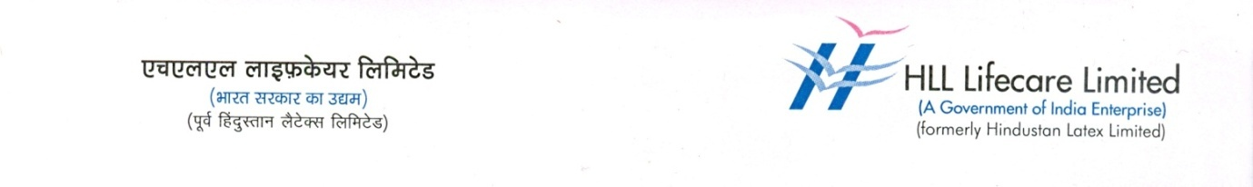
PRESS RELEASE

IOC & HMA joins together to launch

a unique initiative to tackle Anaemia in women

14 February 2023 : Indian Oil Corporation and the HLL Management Academy, the educational and social development initiative of HLL Lifecare Limited, jointly launches an innovative project titled Swasthya to tackle anaemiaamong women of reproductive age, which has remained a prolonged and unrecognized issue affecting the women's health in the state. The project was officially inaugurated by Shri. P. Rajeev, Minister for Industries, Law and Coir, Govt of Kerala on 12 February 2023 during the Oppam Super Speciality Medical Camp at Kalamassery, Ernakulam.

The project, whichis funded by IOCL, aims to improve the quality of lives of anaemic women by creating awareness about the condition and by fostering strategies to tackle the issue. TheSwasthya project will be implemented in Ernakulam district and is estimated to reach out to 15,000 beneficiaries.

Anaemia is a significant public health challenge in India. Ithas disastrous impacts on physical and mental health,productivity, and quality of life. It is very common across allage groups, with a concentration particularly high amongthe most vulnerable such as pregnant women.

In a study conducted among reproductive women in India,it was found that iron deficiency prevalence is higheramong them, which that led to many serious conditions like dysfunctional uterinebleeding.

Swasthya aims to raise awareness about the importance of a balanced diet in preventing Anaemia, as well as provide access to nutritional supplements and iron-rich foods.

As part of Swasthya, free medical camps will be conducted in targeted areas. The camp will have three sessions - health awareness, diagnosticsessions andmanagement session. The project will operate with the support of local specific groups like SHGs, ASHA workers, NGOs etc.

