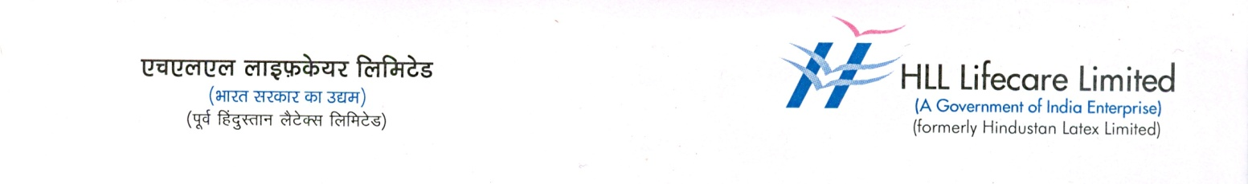

Press Release
09 July 2021

HLL Launches MITU – the condom Kid

As part of World Population Day 2021, HLL Lifecare Limited, one of the largest condom producers in the world has launched MITU-a Condom kid Mascot on 09 July 2021. Mr Santhosh Cherian, CFO & Senior Vice President (Finance) and Mr L. Ajith Kumar, Vice President (IT) launched MITU at a function held today at HLL’s Corporate Head Office. MITU carries a message – I’m Your Best Friend, I’ ll Safeguard You”. The campaign will be rolled out across India to create awareness on the usage of condoms. Arrangements have also made for the free distribution of condoms at various locations on Monday. A selfie contest “Selfie with MITU” is also launched in the Social Media pages as part of the celebrations.
HLL, a Mini Ratna Enterprise under the Ministry of Health and Family Welfare of the Govt. of India is India’s leading providers of a wide range of contraceptives, hospital products, pharma products and health care solutions.

