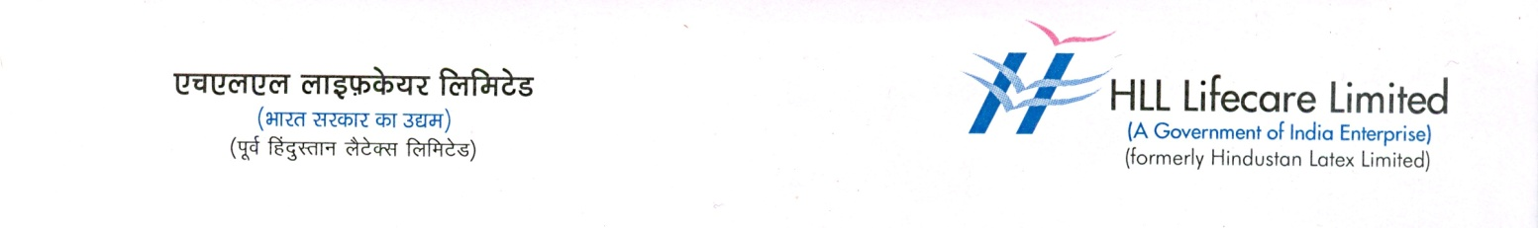

Press Release
22 April 2021

NABL ACCREDITATION FOR HINDLABS TRIDA

Hindlabs Diagnostic Centre & Speciality Clinic, an initiative of HLL Lifecare Limited, the Govt of India Public Sector Enterprise has received the prestigious accreditation from NABL (National Accreditation Board for Testing and Calibration Laboratories). The centre has been assessed and accredited in accordance with the standard ISO 15189: 2012 “Medical laboratories-Requirements for quality and competence” in the field of medical testing.

Laboratory tests that falls under Biochemistry, Immunology, Microbiology, Hematology and Clinical pathology, will come under the purview of NABL.

Hindlabs, at TRIDA- Sopanam Complex, Medical College Thiruvananthapuram, provides high quality lab services and OP clinic at affordable costs to the public. Hindlabs’ 24-hour laboratory services are made available at 30-60 percent lower than private labs.

The centre, set up in May 2016, provides diagnostic facilities in the field of Clinical biochemistry, Hematology, Clinical pathology, Serology and Microbiology and provides well standardized laboratory services by ensuring best quality results. The centre also offers polyclinics like General Medicine, Pulmonary Medicine, Cardiology, Orthopaedics, ENT, Endocrinology and Gynaecology. Other facilities include Echo, ECG, TMT,PFT, X-ray, USG scanning, Doppler scanning, Foetal scanning, Physiotherapy, Dental and Neurolab.

Hindlabs has blood collection centres at various locations like Nedumangaud, Kowdiar, General Hospital, Vattiyoorkavu, Akkulam and Peroorkada.

The centre regularly conducts Medical camps, and undertakes B2B model business with other organizations/institutes/laboratories. Hindlabs supports Electrocardiograph/Cardiology consultation of RCC patients. The centre also supports clinical studies of Medical college departments, Project/Research of Sree Chitra Tirunal Institute of bio sciences, RCC and Medical college.

On an average around 300 people avail Hindlabs (TRIDA) services per day.

HLL has 46 Hindlabs Imaging Centres and 223 Hindlabs Diagnostic Labs on pan India basis.

