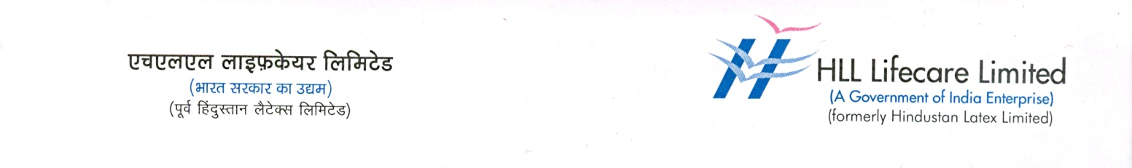

Press Release

HLL celebrates International Women's Day

Thiruvananthapuram, March 08: The International Women’s Day was celebrated at HLL Lifecare Limited (HLL) on March 8.

Inaugurating the programme held at HLL Peroorkada Factory, Nirbhaya State Coordinator R. Nishanthini, IPS, reminded that the aim of the celebrations is to reinforce the concept of gender equality instead of trying for dominance over men.

“There is rampant misuse of the term ‘women’s equality’ and so many complaints are cropping up in this regard,” she added.

V. Kuttappan Pillai, Unit Chief, HLL Peroorkada Factory presided over the function. M. Sreekumari, Secretary, Mahila Mandiram, Poojappura; V. Saraswathy Devi, Associate Vice President, HR, HLL; and Dr. V.K. Jayasree, Deputy General Manager, Hindi Department, HLL attended.

