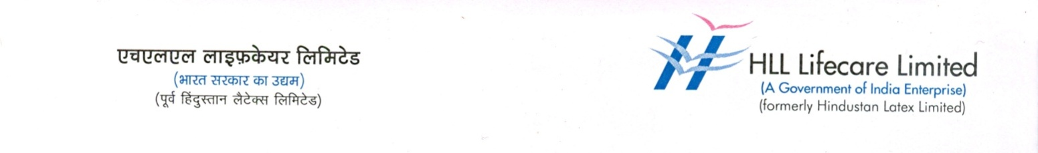

Press Release
Malabar’s first Lifecare centre opens at Vadakara
Kozhikode, Mar 1: Union Minister of State for Home Affairs Shri. Mullapally Ramachandran inaugurated the State’s fourth Lifecare Centre, and the first one in Malabar region at the Vadakara District Hospital here today.
The Lifecare Centre, a joint venture of the central public sector unit HLL Lifecare Limited and the Government of Kerala, provides high quality surgical equipment, surgical implants, glasses, lenses, frames and related medicines at reasonable prices under one roof. The inaugural function was attended by Sri. C.K. Nanu - MLA, Smt. P.P. Renjini - (Chair person, Vadakara Municipality), Sri. Titus. H - ( Municipal Engineer) Smt. A.P. Prajitha - (Chairperson, aarogyam Sthiram Samiti) and Sri. C.V. Asokan - (Councilor). Dr. P.K. Mohanan -(District Medical Officer), Sri. S.Gireesh Kumar -( Group Head, HLL Lifecare Limited) and Sri. Peeyush M. Namboothirippad -( Superintendent, Vadakara District Hospital) were also present during the occasion.

The surgical implants and other medical products are made available at the centres at discounts ranging from 10 to 60 percent. For example the interlocking set which is used in the surgery of the thigh bone costs around Rs 7,000 in the market, but is priced at just Rs 2,200 at the Lifecare centre. Likewise, the AMP implant which is used in bipolar surgeries has a market price of Rs 4,000 but is available at the centre for Rs 1,700. In addition to subsidised services for the needy, the centre will also provide cashless services to RSBY card holders.
The Lifecare Centre at the Vadakara District Hospital is the first in Malabar. As of now, there are three such facilities in Kerala and one in Odisha. The Lifecare Centre at the Thiruvananthapuram Medical College that started functioning in October 2011 was the first in this chain. The other two Lifecare centres are at the Pathanamthitta General Hospital and the Thiruvananthapuram Regional Institute of Ophthalmology.
In view of private agencies charging different rates at different hospitals for surgical and ophthalmic equipment, the Lifecare Centre will help address the uncertainties and lack of proper systems in this sector. Through the Lifecare Centres, HLL aims to ensure standardisation and transparency in the marketing of these products and deliver them to the common man at reasonable prices.
The state Government has given its approval for opening Lifecare Centres at four other Government Medical Colleges in Kerala and at district and taluk hospitals. The goal is to make vital medical equipment and products accessible to patients depending on Government hospitals. With its mission of making quality healthcare and services available to all people, HLL Lifecare Limited is today a major player in the global health sector.

