TENDER FOR THE DISPOSAL OF
MISCELLANEOUS SCRAP MATERIALS
HLL/AFT/MTLS/SCRAP-SALES /2021-22

INVITATION FOR BID

TENDER NOTICE
HLL/AFT/MTLS/SCRAP-SALES /2021-22 Dated: 13.01.2022

Sealed, super-scribed and competitive tenders are invited for finalizing annual rate contract for the disposal of miscellaneous scrap materials, as indicated below, at our Akkulam Unit on cash and carry basis. Details/Documents can be obtained from HLL website: http://www.lifecarehll.com/tender
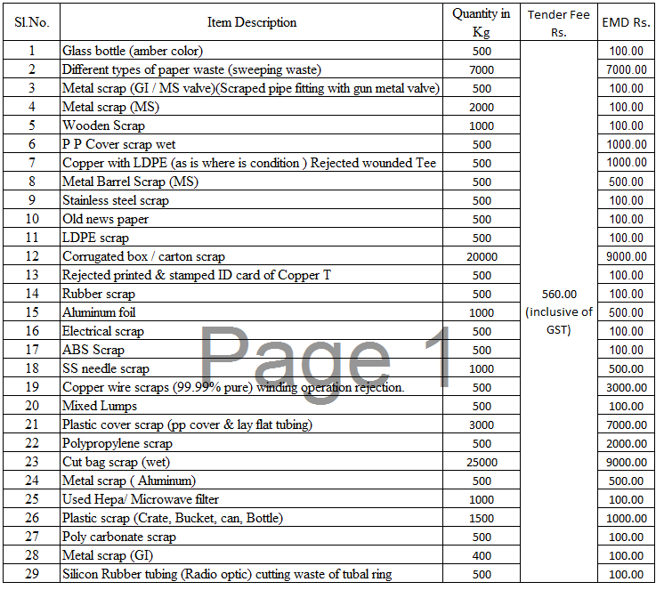
The last date & time of receipt of bid: 28.01.2022 01.00 pm
Date of opening of bid : 28.01.2022 03.00 pm
Joint General Manager (Materials)
PH : +91 471 2445930
FAX: +91 471 2445935
Email: materialsaft@lifecarehll.com

TERMS & CONDITIONS
- Rate offered should be the basic rate. The rates should be quoted based on the quantity in price Bid Annexure ‘A’ attached. Taxes are payable by the Contractor/bidder as applicable at the time of taking delivery. If the concessional rate of Tax is to be levied by HLL Lifecare Ltd. (hereinafter called HLL) necessary Forms are to be submitted in advance. TCS will be as applicable at the time of delivery.

- The Value of the scrap along with applicable rate of Tax/Duty must be paid in advance by way of RTGS/NEFT/DD, drawn in favour of HLL Lifecare Ltd., Trivandrum, at our cash counter prior to the clearance of the scrap materials, In case the Amount of DD, so handed over to our Cash counter, is found insufficient after the actual weighing of the scrap Materials the contractor/bidder should remit the balance amount immediately at our Cash Counter by cash. In case the amount exceeds Rs.10000/- the amount should be paid by RTGS/NEFT/DD in favour of HLL Lifecare Ltd., Trivandrum.

- HLL has the right to reject any Tender without assigning any reason.

- The Scrapped Items/Equipment/Machines are offered in ‘As is where condition is’ and can be inspected during office hours on any working day. It is the responsibility of the buyer to inspect the items and take delivery of the items. The company will not entertain any complaints on the quality, quantity, etc after the materials were taken delivery by the buyer.

- The Contractor/bidder should arrange for the removal of the scraps immediately after the intimation from the concern. This may be strictly adhered to the party. If not willing to remove the scrap within 7 days from the date of written intimation from Sales Department/Security gate/Stores, the party has to pay an additional 10% of total scrap value as penalty.

- It must be clearly understood that the contract is an Item wise contract and the Sale order will be issued to H1 parties based on the rate quoted for each items. Bidders can bid for all items or for items of their choice

- The bidders are required to submit along with an EMD & Tender Fee amount as mentioned in Schedule B, by way of demand draft, drawn in favor of HLL Lifecare Ltd., payable at Trivandrum. This amount does not carry any interest. The EMD amount of successful Bidder will be retained till the contract period is over. The EMD amount of the other Bidders will be returned after finalizing the Tender. The completed Tenders, addressed to the Joint General Manager (Materials), HLL Lifecare Ltd., Akkulam, Sreekariyam P.O., Trivandrum – 695 017, along with required EMD & Tender Fee must reach the addressee on or before 28.01.2022 (before 1.00 PM). The Tenders so received would be opened at 03.00 PM on same day. The late and incomplete Tenders and the Tenders without EMD & Tender Fee will be rejected out rightly.
- The vehicle for loading the scrap materials should report to our sales Department by 10.00 AM during company working days. The contractor/bidder at his cost shall arrange the weighing and loading of the scrap materials. For loading, the contractor should utilize the service of the local unionized Head Load Workers. The vehicle laden with scrap materials will be checked out through HLL main gate only on the basis of gate pass, issued by the Sales Department. The scrap materials once sold would not be taken back at any cost.

- Any accident or loss of life while loading the materials would be solely the responsibility of the bidder/contractor. Company would be in no way entertain any claim in this regard.

- The contractor/bidder should ensure that no damage or loss is caused to the company property while clearing the scrap materials and the contractor is liable to make good such damage/loss immediately, if any, as per the decision of HLL. The contractor/bidder shall ensure that the persons engaged by them for handling the scrap materials at the factory are not indulging in any malpractice, pilferage, etc.

- Tender Documents, containing terms and conditions etc, can be had from our Office on any working day between 10.30 AM to 2.30 PM from 14.01.2022 to 27.01.2022 by paying a Tender fee of Rs.560.00 (Inclusive of GST) by Cash/DD, drawn in favour of HLL Lifecare Ltd., payable at Thiruvananthapuram or can be downloaded from our website http://www.lifecarehll.com/tender in which case a DD for Rs.560.00 (inclusive of GST) drawn in favour of HLL Lifecare Ltd., Trivandrum, shall be forwarded along with completed tender.

- Period of contract will be for “ONE YEAR” from the date of issuance of the Sale Order.

- All disputes or differences whatsoever arising between the contractor/bidder and HLL shall be settled by arbitration in accordance with the Rules of Arbitration of the Indian council of Arbitration and the awards made in pursuance there of shall be binding on both parties. All arbitration proceedings shall come under Trivandrum Jurisdiction.

- Non-compliance of any of the terms and conditions would tantamount to automatic termination of the contract, forfeiting EMD.

- The scrap materials can be inspected during office hours on any working day. HLL will have the discretion to divert any quantity of available scraps for its own use or for the use of other genuine consumer/trader, if the situation so warrants.

- In case of sweeping waste, party has to clear the scrap every 10 days & segregation of the scraps will not be allowed. Sweeping waste & other scraps lying at Bag Cutting area should also be removed by the party in every 10 days period.

- It is the responsibility of the party to remove various scrap stored at different locations of the factory, like scraps stored in various floors, terrace and other locations.

- In case the party is not removing the scrap as per the instruction from the Sales Department, the Security Deposit amount will be forfeited & additional expenses incurred for alternative arrangements for removing the scrap will also have to paid by the party as penalty.

- The bidders/contractors are required to sign on all pages of the tender document. The incomplete tenders, without copy of ID & Address Proof and proper signature will be rejected. PAN & GST is mandatory

- SSI / MSME bidders can avail exemption for Tender fee & EMD by submitting valid Udyog Aadhar / Udhyam certificate. MSME bidders may declare whether they are women entrepreneur or not, also declare their social category (Gen/SC/ST/OBC/Others). MSME bidders have to sign a bid security declaration (Annexure B)

*************************

Schedule A

page 1 of 1

DECLARATION BY THE TENDERER

I/We fully understood the Terms and Conditions of the tender, which are being returned herewith duly signed by me/us of having accepted the same to and I/We have made my/our offer keeping in view of those terms and conditions.

NAME OF TENDERER………………………………………………………………………….

ADDRESS OF TENDERER …………………………………………………………………….

……………………………………………………………………………………………………………

……………………………………………….……PH.NO……………………………..……

ID & Address Proof …………………………………………………………………………..……..
(Aadhar Card / Driving license / Election ID etc.)
Are you a MSME Bidder: YES / NO. (If yes, attach copy of Udyog Aadhar / Udhyam)
- If yes, Please mention your social category – SC / ST / OBC
- If yes, whether you are a women entrepreneur - YES / NO

GST ID: ………………………………..…………… PAN NO: ……………………………

BANK ACCOUNT NO.OF TENDERER …………………………………………………

TYPE OF ACCOUNT: ……………………………………………………………………

NAME OF THE BANK ……………………………………………………………………

ADDRESS OF THE BANK ……………………………………………………………….

………………………………………………………………………………………………

PLACE:………………….
DATE: …………………...

NAME AND SIGNATURE OF THE TENDERER
(WITH OFFICE SEAL)
Schedule B
Tender Fee & EMD Details
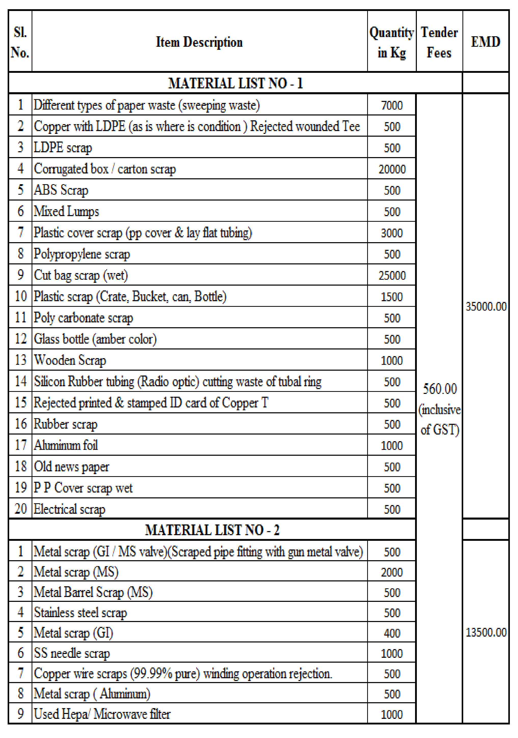

Place: NAME AND SIGNATURE OF THE TENDERER
Date: (WITH OFFICE SEAL)

INVITATION FOR BID
PRICE BID

FOR

TENDER FOR THE DISPOSAL OF
MISCELLANEOUS SCRAP MATERIALS
HLL/AFT/MTLS/SCRAP-SALES /2021-22

Annexure - A

page 1 of 2
PRICE BID FORM 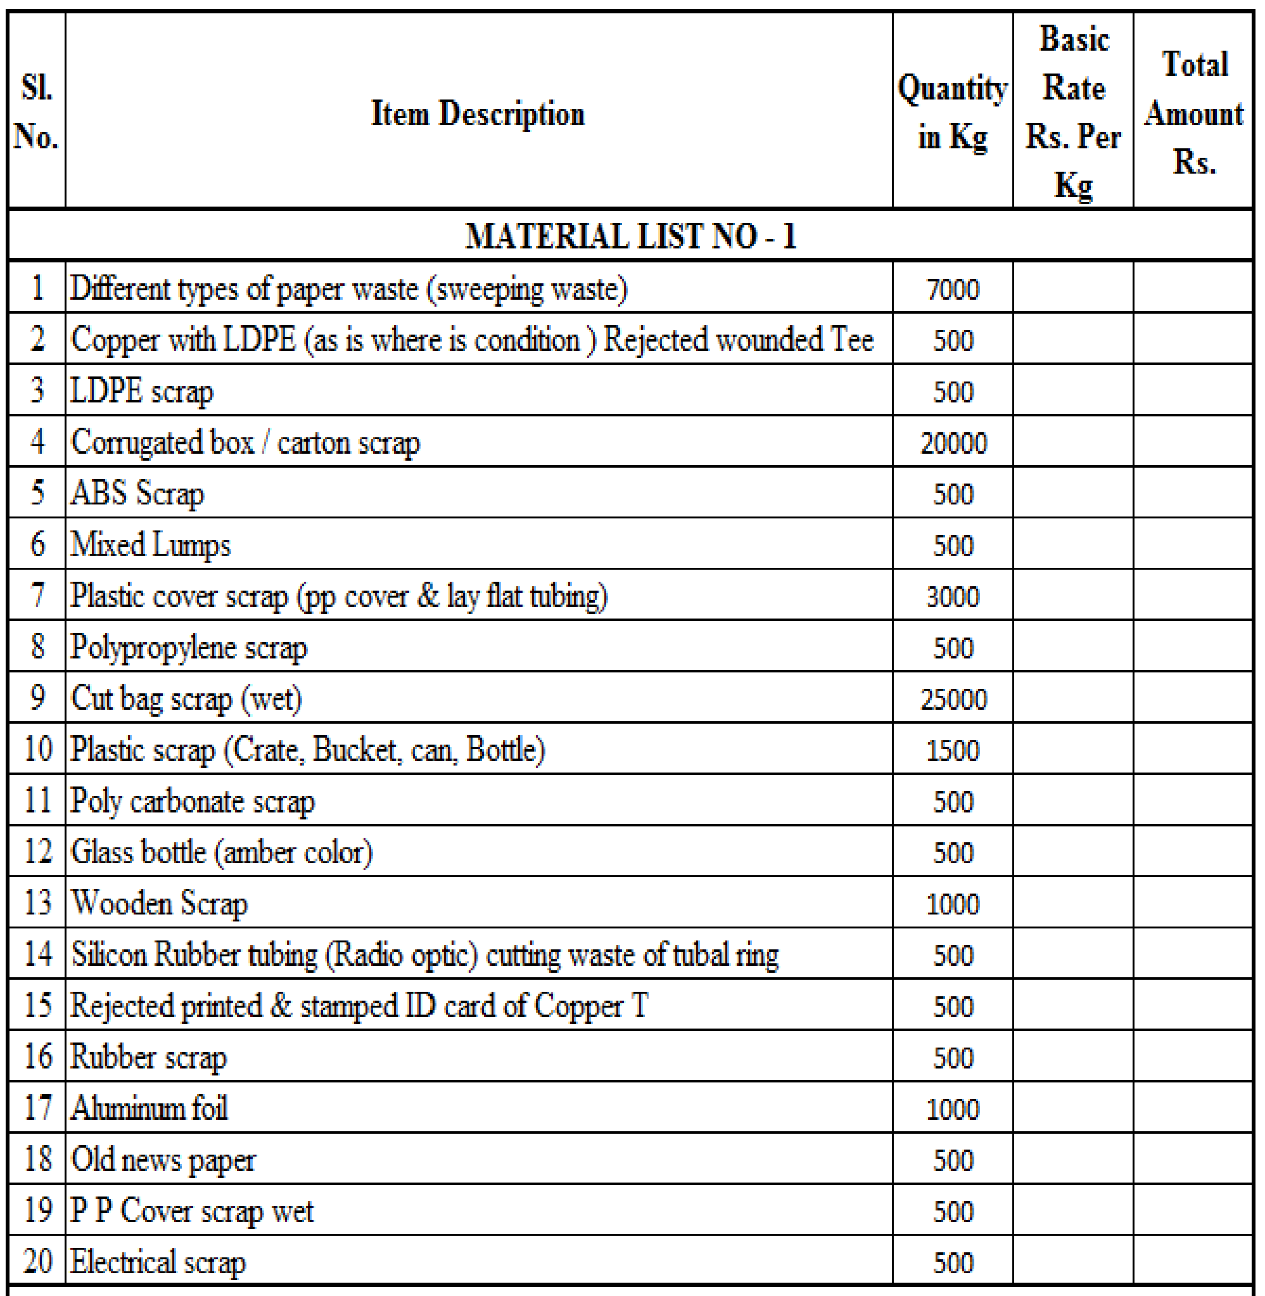
Contd………….

Annexure - A

page 2 of 2
PRICE BID FORM
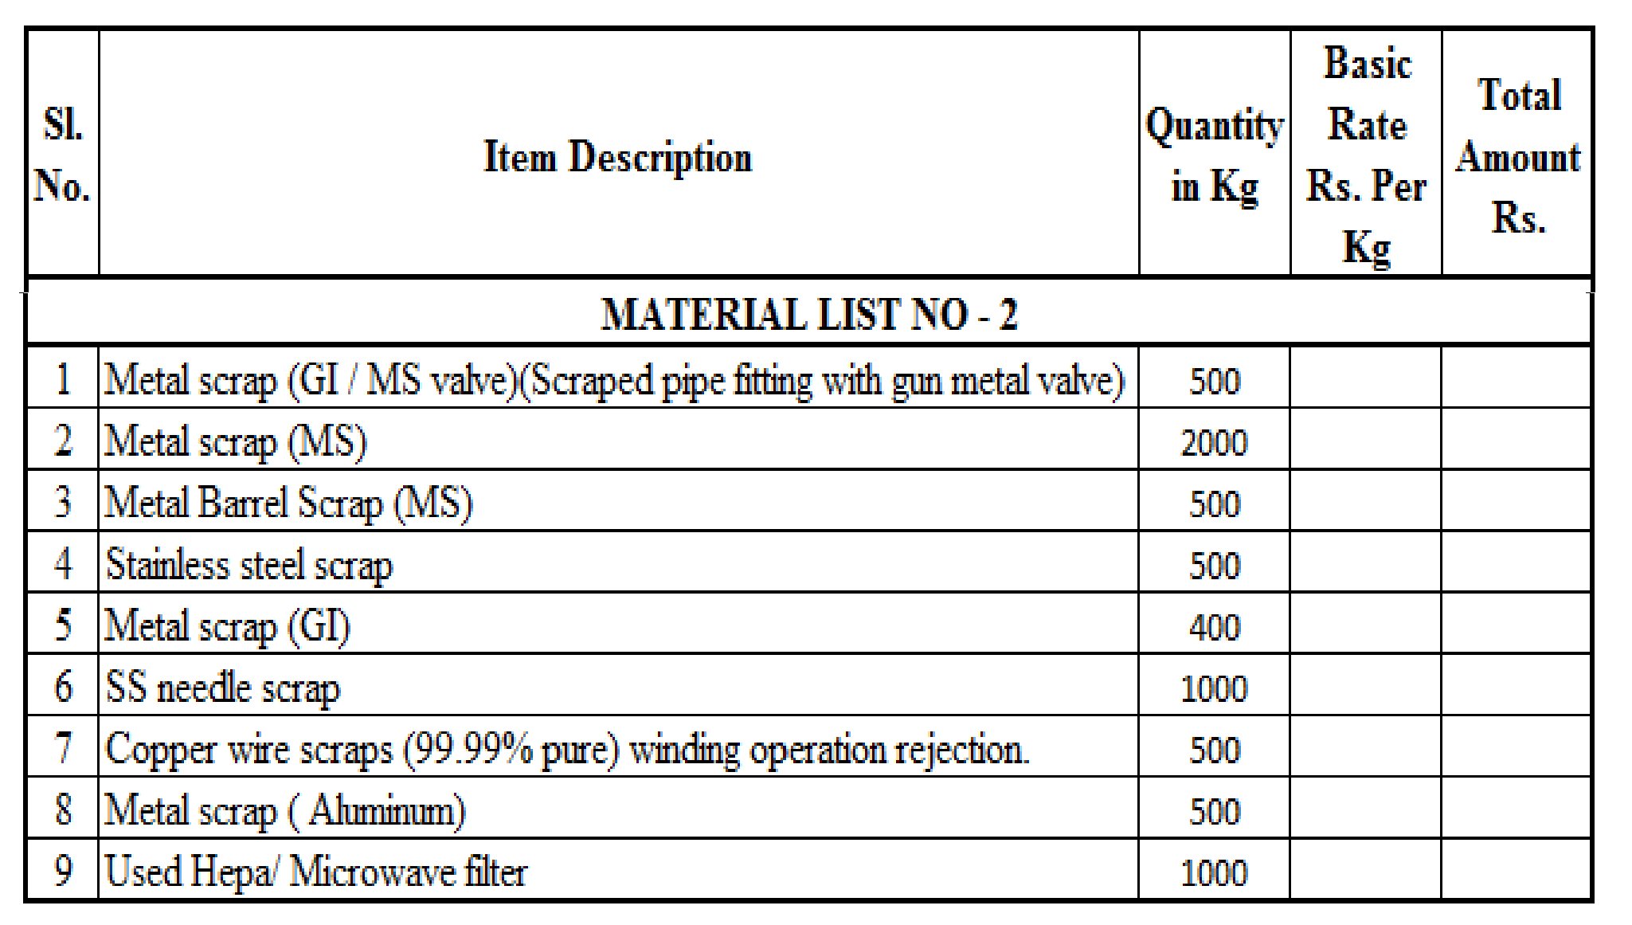
Rate offered should be the basic rate. The rates should be quoted on per Kg. Taxes are payable by the Contractor as applicable at the time of taking delivery. If the concessional rate of Tax is to be levied by HLL Lifecare Ltd. (hereinafter called HLL) necessary Forms are to be submitted in advance. TCS @ 1% need to be paid at the time of taking delivery.

NAME AND SIGNATURE OF THE TENDERER
Place:
Date: (WITH OFFICE SEAL)

Annexure - B

page 1 of 1
Bid Security Declaration Form

Date: Tender No.

To (insert complete name and address of the bidder)

I/We. The undersigned, declare that:
I/We understand that, according to your conditions, bids must be supported by a Bid Securing Declaration.
I/We accept that I/We may be disqualified from bidding for any contract with you for a period of one year from the date of notification if I am /We are in a breach of any obligation under the bid conditions, because I/We
- have withdrawn/modified/amended, impairs or derogates from the tender, my/our Bid during the period of bid validity specified in the form of Bid; or
- having been notified of the acceptance of our Bid by the purchaser during the period of bid validity (i) fail or reuse to execute the contract, if required, or (ii) fail or refuse to furnish the Performance Security, in accordance with the Instructions to Bidders.
I/We understand this Bid Securing Declaration shall cease to be valid if I am/we are not the successful Bidder, upon the earlier of (i) the receipt of your notification of the name of the successful Bidder; or (ii) thirty days after the expiration of the validity of my/our Bid.

Signed: (insert signature of person whose name and capacity are shown)
in the capacity of (insert legal capacity of person signing the Bid Securing Declaration) Name: (insert complete name of person signing he Bid Securing Declaration)
Duly authorized to sign the bid for an on behalf of (insert complete name of Bidder) Dated on day of (insert date of signing) Corporate Seal (where appropriate)

