HLL LIFECARE LIMITED
(A Government of India Enterprise)
AKKULAM PLANT, SREEKARIYAM P.O,

THIRUVANANTHAPURAM-695017
Email: materialsaft@lifecarehll.com
Website: www.lifecarehll.com
PH: +91 471 2442641, 2445930
FAX: +91 471 2445935

INVITATION FOR BID

(TECHNICAL BID)

FOR

Design, Fabrication, Supply & Qualification of:

HOT RUNNER MOULD FOR IUD Cu 380A

Quantity: 1 Number

AT

AKKULAM FACTORY
THIRUVANANTHAPURAM – 695 017

HLL/AFT/PUR/MOULD/CU-380A/2015-2016 dtd 08/02/2016

TENDER NOTICE

Sub:- Design, Fabrication, Supply & Qualification of HOT RUNNER MOULD FOR IUD Cu - 380A

Sealed and superscribed tenders under two bid system are invited from manufacture(s) / Authorized Agent(s) for design, fabrication, supply and qualification of Hot runner mould IUD Cu 380A- One Number at HLL Lifecare Ltd, Akkulam Plant.

Name of the Item | Tender No: | Date & Time of Receipt of bids | Delivery
HOT RUNNER MOULD FOR IUD Cu 380A | HLL/AFT/PUR/  Mould/CU-380A/2015-2016 | 25/02/2016  at  3.00 PM | 90 days  (From the date of LOI/PO)

The detailed Tender Notice and tender documents can be downloaded from our website www.lifecarehll.com. Amendments if any to this tender notice will be published only in our website.

Date of the tender opening is 25/02/2016 at 4.00 pm

JGM (Mtls)
Ph No: +91 471 2445930

Fax No: +91 471 2445935

Email: materialsaft@lifecarehll.com

HLL LIFECARE LIMITED
Akkulam Factory, Sreekariyam (PO)
THIRUVANANTHAPURAM-695017

CONTENTS OF BIDDING DOCUMENTS

Sl No | Schedule | Description | Page No
1. |  | INSTRUCTION TO BIDDERS | 4-5
2. | Schedule – A | WORK CONDITIONS, | 6-8
4. | Schedule – B | QUESTIONNAIRE | 9-10
5. | Schedule – C | TERMS & CONDITIONS | 11-13
7. | Schedule – D | INDEMINITY CLAUSE | 14
8. | Schedule – E | DECLARATION | 15
9. | Schedule – F | PRICE BID | 17-18

***

HLL LIFECARE LIMITED
(A Government of India Enterprise)
AKKULAM PLANT, SREEKARIYAM P.O,
THIRUVANANTHAPURAM-695017

HLL/AFT/PUR/MOULD/Cu-380A/2015-2016 dtd 08/02/2016

I - INSTRUCTIONS TO BIDDERS

1. The Bid is intended to procure material as per specification in Schedule A.
2. This is a two Bid system comprising of:
- Technical Bid
- Price Bid
3. Both the Bids shall be submitted in sealed covers separately. Tender Nos. of the Technical Bid and Price Bids shall be super scribed on the respective covers in order to clearly identify between the 2 Bids. The two separately marked Bids enclosed in a single sealed cover with the respective Tender No. mentioned thereon, complete in all respect, addressed to the The Joint General Manager (Materials) HLL Lifecare Limited, Akkulam Factory, Trivandrum – 695017, Kerala, India should reach us on or before the due date and time mentioned in the Tender Notification. HLL shall not be responsible for any delay. Tender brought to the office after prescribed time will not be accepted. HLL will not be responsible for any delay in transit of tenders sent by post.

4. Eligibility: Party should have 3 years of experience in the similar work (Party should submit supporting documents also for the same)

5. The technical bid should accompany an EMD the details are shown in clause 3 of schedule C.

6. In the event of the date mentioned above being declared subsequently as holiday for the purchaser’s office, the due date for submission and opening of bids will be the next working day at the same venue and time.

7. The Purchaser may, at its discretion, extend the date & time for the submission of bids by amending the bid documents in which case, all rights & obligations of the Purchaser & bidders shall the subject to the extended date & time.

8. Bids received after the deadline for submission shall not be considered.

9. The Bidder is expected to examine all specifications, Mould design concept drawing, Instructions, Forms, terms and conditions given in the Bidding documents. Failure to furnish all information required in the Bidding documents or submission of a Bid not substantially responsive to the bidding documents in every respect will be at the Bidders risk and may result in rejection of the Bid. Any clarification required will have to be obtained from our office.

HLL LIFECARE LIMITED
(A Government of India Enterprise)
AKKULAM PLANT, SREEKARIYAM P.O,
THIRUVANANTHAPURAM-695017

HLL/AFT/PUR/MOULD/Cu-380A/2015-2016 dtd 08/02/2016

10. A Declaration as given in Schedule - E stating that ALL TERMS AND CONDITIONS of this Tender is acceptable should accompany the tender failing which the tender is likely to be summarily rejected.

11. The Price Bid of those Tenderers who qualify in the Technical Bid only will be opened.

12. Those bidders who download the tender documents from our website should furnish the Name and address of the vendor, name of contact person, telephone & Fax numbers and Email details immediately by fax/Email.

13. Any changes pertains to this tender shall be communicated only through our website www.lifecarehll.com.

Schedule – A

HLL LIFECARE LIMITED
(A Government of India Enterprise)
AKKULAM PLANT, SREEKARIYAM P.O,
THIRUVANANTHAPURAM-695017

HLL/AFT/PUR/MOULD/Cu-380A/2015-2016 dtd 08/02/2016

TECHNICAL SPECIFICATION & GENERAL CONDITIONS

HOT RUNNER MOULD FOR IUD 380A (NEW)

Specifications

- Item name: Hot Runner Mould for IUD 380A (New)
- No. of cavities: 8
3. Component Drawing No. HLL/AFT/IUD- 380A/2015
4. Component Material: T Blend (LDPE with 20% Barium Sulphate)
5. Type of mould: 2 Plate Hot Runner with single point hot tip
(should not have any cold sub runner)
6. Type of gate: Pin point gate.
7. Material for Mould base: P20
8. Mould base: DME / HASCO standard
9, Hot runner system: Thermoplay, Itally/ Mold Masters.
10. Material for Cavities & Cores: STAVAX ESR/other superior grade, Fully hardened (50 - 54 HRC), ground and polished.
11. Material for Core pins: STAVAX ESR
12. Ejector system: Automatic.
13. Ejector pins & Pushback pins: Suitable grade material to be used for the manufacturing of pins and also provide suitable surface treatment / coating, if required for the proper functioning of the mould.
14. Guide pillar & Bush: Suitable grade material to be used for the manufacturing of guide pillar and bush (surface hardness 55 to 60 HRC).
15. Other parts: Use only good quality tool steel
16. Quality parameters on the moulded component to accept the mould:
a. Physical dimensions of the component: As per the part (component) drawing
a.. Allowable parting line limit : 50 micron
b.. Allowable gate projection : 100 micron (there should not be any gate projection above the component surface if dimple is provided at gate area).
c. Allowable ovality : 80 micron
17. Minimum mould life: 15 Lac shots.
18. Mould Guarantee period: one year from the date of mould acceptance (all parts including hot runner, controller, core pins, ejector pins, etc.).

19. Others.
a) Do not stick the components in cavities or on core pins while ejecting the components, components must fall freely. The operation of the mould must be smooth and trouble free.
b) Mould must be suitable to operate without using mould release spray.
c) Cavity numbers to be engraved.
d) The components must be free from flash, bend, ovality, deformation, etc.
e) All sliding parts must be good quality tool steel (non-corrosive) hardened and ground.
f) Use only superior quality springs; two (2) full sets of springs must be supplied along with the mould as spare.
g) Delivery period: Mould fabrication, Trials & supply of mould must be within 70 days from the date of Purchase Order (PO)/Letter of Intent (LOI)
h) Detailed Mould drawing (Soft copy and one set of hard copy) must be supplied along with the mould including part drawings. Mould concept drawing must be supplied along with the quotation.
i) All the electrodes which are used for the mould fabrication must be supplied along with the mould.
j) Detailed spare parts list, detailed drawing of spare parts including material specification also to be supplied along with the mould.
k) One set of core pins and ejector pins (suitable to change in any cavity) must be supplied along with mould as spare without additional cost.
l) The overall construction of the mould must be sturdy and long-lasting.
m) Raw material for mould trial will be supplied by HLL
n) Temperature controller -12 Zone Temperature controller

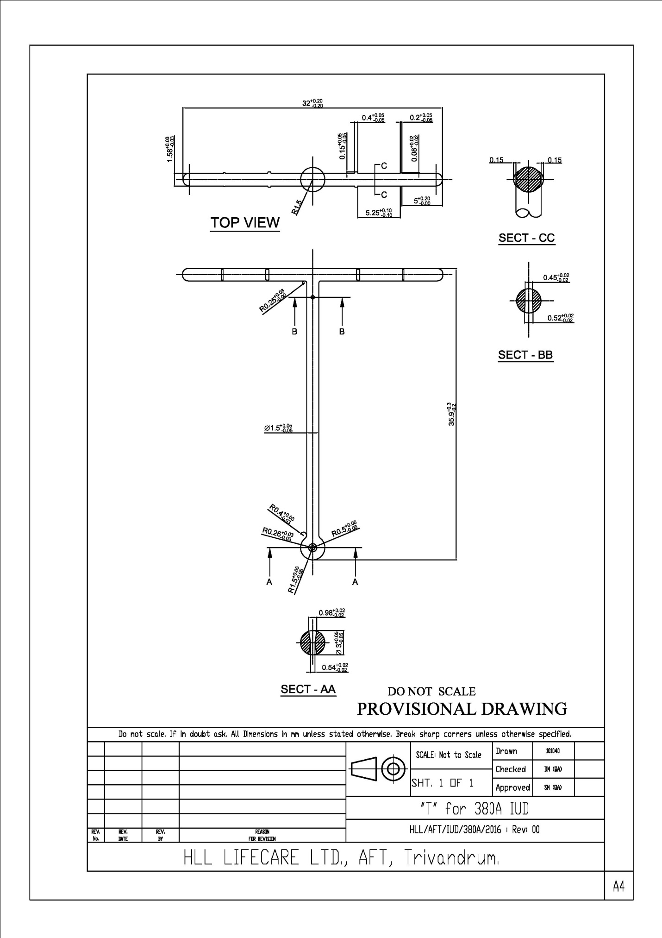

ScheduleB
1 of 2

HLL LIFECARE LIMITED
(A Government of India Enterprise)
AKKULAM PLANT, SREEKARIYAM P.O,
THIRUVANANTHAPURAM-695017

HLL/AFT/PUR/MOULD/Cu-380A/2015-2016 dtd 08/02/2016

III. QUESTIONNAIRE

(General information of the supplier)

1. Name & Address of the supplier with :
(a) Telephone No.
(b) Fax No.
(c) E – mail Address
(d) Name of the contact person
(e) Whether proprietory / partnership /
Limited company.
(f) Specify whether SSI / MSME unit

2. Are you a manufacturer, authorized :
Dealer or any other? If authorized agent,
A copy of the original letter from the
Manufacturer / Principal, duly attested,
Should be furnished conforming the agency

3. How many years have you been in the :
business of manufacturing

4. What would be the minimum period :
required to deliver the mould from the date of
confirmed Purchase order?

5. Have you been a supplier / manufacturer, :
if so details of the name, address,
quantity and values of orders
received and executed during
last three years? (Attach separate sheet)

Schedule – B
Page 2 of 2
6. Brief details of the machinery, instruments :
and technical staff
(attach separate sheet if required)

7. Name of major customers
(attach separate sheet if required)

8. What is your Annual Turn Over during the :
last 3 years?

9. What is your :- :
a) CST No :
b) VAT NO /TIN NO :
c) Central Excise Registration No: :
d) PAN No :

10. Name & Address of your Banker(s) :

11. Any other details :

All the information provided herein is true & correct.

PLACE: NAME & SIGNATURE OF THE APPLICANT
DATE: (WITH OFFICE SEAL)

***

Schedule – C
Page 1 of 3

HLL LIFECARE LIMITED
(A Government of India Enterprise)
AKKULAM PLANT, SREEKARIYAM P.O,
THIRUVANANTHAPURAM-695017

HLL/AFT/PUR/MOULD/Cu-380A/2015-2016 dtd 08/02/2016

IV. TERMS & CONDITIONS

1. The tender should be completed in all respects; incomplete tenders are liable to be rejected.
2. Unsealed tenders received are liable to be rejected and this will be at the sole risk of the tenderers.

3.Earnest Money deposit (EMD)

  - Technical Bid should accompany a DD drawn in favour of M/s.HLL Lifecare Limited, and payable at Thiruvananthapuram for a sum of Rs. 25,000/- (Rs. Twenty five Thousand only) towards Earnest Money Deposit failing which the Tender is likely to be summarily rejected. SSI/MSME units interested in availing exemption from payment of Tender Fee & EMD should submit a valid copy of their registration certificate issued by the concerned DIC or NSIC. But the Party has to provide Security deposit if Tender is awarded to them.

  - Release of EMD: The EMD of unsuccessful tenderers will be refunded soon after finalisation of tender, or after two months from the date of opening of tender whichever is earlier. The EMD will not bear any interest.

  - Forefeiture of EMD: The EMD will be forfeited by the HLL in case, after submitting the tender, the tenderer withdraws his offer or fails to supply after the receipt of Purchase Order.

4. SUPPLY:
The successful tenderer will have to supply the machine within the stipulated delivery time mentioned in the Purchase order.

5. PERIOD OF VALIDITY OF TENDER:
The tender will remain open for acceptance for 30 days from the date of opening of the tender and the rate quoted shall be firm and valid for a period of 90 days from the date of opening of the quotation.

6. TERMINATION OF CONTRACTS:
In case, after issue of a firm order, the successful tenderer fails to supply the item as per the specified quality and the required quantity according to the Delivery Schedule as given in the Supply Order, and even fails to complete the supply within the extended period if any given in writing by HLL Lifecare Limited, Thiruvananthapuram, it will be within HLL’s full rights to terminate the contract by giving a notice of 21 days in writing sent by Registered courier to the address given in the tender submitted or
Schedule – C
Page 2 of 3

to any other address which may be recorded in the office at the request of the tenderer. The period of 21 days will be counted from the date of issue of the notice.

In case of notice sent by registered post/ courier to the address recorded in the office as is returned undelivered with the remark addressee not found or addressee refused to accept, the notice shall be deemed to have been served and the termination will automatically take effect from the 22nd day of dispatch of the notice.

HLL Lifecare Limited, will have the full right to reject any or all the tenders without assigning any reason whatsoever. The HLL Lifecare Limited, also reserves the right to award the contract with more than one contractor.

7. PRICE:
Price: The tenderer has to quote the rate for supply of the item as per unit as given in the tender. Statutory levies if any such as Excise Duties, Sales Tax, VAT etc. should be shown separately. Rates quoted should be strictly as per HLL’s format.
Price variation: Rate quoted shall be firm and valid for a period of one year from the date of opening of the tender. The benefit of reduction of statutory levies should be passed on to the purchaser.

8. RELEASE OF PURCHASE ORDER:
The purchaser may consider placement of a purchase order for commercial supplies on those bidder(s), whose offers have been found technically, commercially and financially acceptable.

During the period of contract, if so desired by the purchaser, the supplier (s) premises shall be visited by the purchaser for inspection/evaluation.

9. PAYMENT:

- 90% of the payment on acceptance of Mould at HLL Lifecare Limited, Akkulam.
- The balance 10% payment shall be released against a Performance guarantee valid for a period of one year from the date of the issue of final “Acceptance certificate of molded component issued by HLL Officials”..
Normally the Purchaser will not entertain any advance payment. However, the bidder can indicate advance payment in the payment terms, if required. Moreover such advance payment, will be released against submission of a Bank guarantee, on a specific format given by the supplier, from a nationalized/scheduled bank for like amount valid up to the supply of equipment at purchaser’s site.

10. Warranty: One year from the date of acceptance of the mould.
Schedule – C
Page 3 of 3

11. PURCHASER’S RIGHT TO ACCEPT ANY BID AND TO REJECT ANY OR ALL BIDS
The Purchaser reserves the right to accept or reject any bid, and to annul the bidding process and reject all bids, at any time prior to award of contract without assigning any reason whatsoever and without thereby incurring any liability to the affected bidder or bidders on the grounds of purchaser’s action.

12. TRAINING
The bidder shall provide necessary training for operation & maintenance staffs of the purchaser at free of cost.

13. Mode of Transport:
By road for Indian Suppliers unless otherwise specified.

14. Despatch documents like delivery note/challan, packing list and invoice should be intimated immediately with the LR No/Shipping Bill No/Air way Bill No.

15. The jurisdiction of any disputes, suits and proceedings arising out of this tender shall be only in the courts of Thiruvananthapuram, Kerala State, India.

16. “Any disputes or difference whatsoever arising between the parties out of or relating to the construction, meaning and operation or effect of this contract or the breach thereof shall be settled by arbitration in accordance with the rules of arbitration of the Indian Council of Arbitration and the award made in pursuance thereof shall be binding on the parties” in case the matter is referred for arbitration.
17. The decision of HLL will be final and no correspondence on this shall be entertained.

18. There will not be any post tender negotiation except with the first lowest responsive bidder.
19. The jurisdiction of any disputes, suits and proceedings arising out of this tender shall be only in the courts of Thiruvananthapuram, Kerala State, India.
20. The decision of HLL will be final and no correspondence on this shall be entertained.

JGM (Materials)

SCHEDULE – D
Page 1 of 1

HLL LIFECARE LIMITED
(A Government of India Enterprise)
AKKULAM PLANT, SREEKARIYAM P.O,
THIRUVANANTHAPURAM-695017

HLL/AFT/PUR/MOULD/Cu-380A/2015-2016 dtd 08/02/2016

V. INDEMINITY CLAUSE:

If the supplier fails to execute the order within the time prescribed for the delivery of goods ordered or violates or infringes the existing rates as agreed to as mentioned in the supply order, the supplier shall and will indemnify the company against all loses or damages whatsoever to be incurred or sustained including the legal cost or expenses incurred by the company by reason of non-delivery of equipment at agreed quantity and rate with in the time specified in the supply order. The company will initiate legal action if the supplier fails to execute the supply order as per the schedule in the supply order for the actual loss suffered. Responsiveness of the Bid shall be at the discretion of HLL.

The supplier shall have no right to change the conditions stipulated in the supply order.

Bid pronounced Non Responsive by HLL shall be summarily rejected.

The decision of HLL will be final and no correspondence of this shall be entertained.

We have read and understood the above conditions and agree to abide by the same.

PLACE: NAME AND SIGNATURE OF THE APPLICANT
DATE: (WITH OFFICE SEAL)

***

SCHEDULE - E
Page 1 of 1

HLL LIFECARE LIMITED
(A Government of India Enterprise)
AKKULAM PLANT, SREEKARIYAM P.O,
THIRUVANANTHAPURAM-695017

HLL/AFT/PUR/MOULD/Cu-380A/2015-2016 dtd 08/02/2016

VI. DECLARATION

We confirm having read and understood all the specifications, instructions, forms, terms and conditions and other requirements of the above tender (both expressed and implied) in full and that we agree to abide by all without any deviation.

SEAL OF THE APPLICANT SIGNATURE

NAME AND ADDRESS OF APPLICANT

***
HLL LIFECARE LIMITED
(A Government of India Enterprise)
AKKULAM PLANT, SREEKARIYAM P.O,

THIRUVANANTHAPURAM-695017
Email: materialsaft@lifecarehll.com
Website: www.lifecarehll.com
PH: +91 471 2442641, 2445930
FAX: +91 471 2445935

INVITATION FOR BID

(PRICE BID)

FOR

Design, Fabrication, Supply & Qualification of

HOT RUNNER MOULD FOR IUD Cu 380A

Quantity: 1 Number

AT

AKKULAM FACTORY
THIRUVANANTHAPURAM – 695 017

SCHEDULE - F
Page 1 of 2
HLL LIFECARE LIMITED
(A Government of India Enterprise)
AKKULAM PLANT, SREEKARIYAM P.O,
THIRUVANANTHAPURAM-695017

VII. PRICE BID

HLL/AFT/PUR/MOULD/Cu-380A/2015-2016 dtd 08/02/2016

NAME OF THE ITEM: Design, Fabrication, Supply & Qualification of

HOT RUNNER MOULD FOR IUD Cu380A

Sl. No: | Particulars | Unit | Qty | Rate (Rs.) | Amount (Rs.)
1. | Design, Fabrication, Supply & Qualification of :  HOT RUNNER MOULD FOR IUD Cu380A | No | 1
2 | Any other expenses
Total Amount (Rs.)
Excise Duty
Sales Tax
Other charges (if any)
Service Tax
Grand Total (Rs.)

SCHEDULE - F
Page 2 of 2

Statutory levies if any :
Any other Remark (s) :

Payment terms:

Certified that the rate quoted will hold good for 90 days, during which period no upward revision will be asked for.

NAME OF TENDERER: ______________________________

Place: ADDRESS AND SIGNATURE OF THE TENDERER Date: (WITH OFFICE SEAL)

