HLL LIFECARE LIMITED
(A Government of India Enterprise)
AKKULAM FACTORY, SREEKARIYAM P.O,

THIRUVANANTHAPURAM-695017
Email: materialsaft@lifecarehll.com
Website: www.lifecarehll.com
PH: +91 471 2442641, 2445930
FAX: +91 471 2445935

INVITATION FOR BID

FOR

Design, Fabrication, Supply & Qualification of

Eight Cavity automatic Hot Runner Tee Mould

Quantity: 1 Number

AT

AKKULAM FACTORY
THIRUVANANTHAPURAM – 695 017

TENDER NOTICE

Sealed and superscribed tenders are invited for Design, Fabrication, Supply & Qualification of Eight Cavity automatic Hot Runner Tee Mould - One Number at HLL Lifecare Limited, Akkulam Factory, Thiruvananthapuram
Name of the Item | Last Date & Time of receipt of bids | Delivery
Design, Fabrication, Supply & Qualification of:  Eight Cavity automatic Hot Runner Tee Mould | 27/04/2022  at 2.00 PM | 90 days  (From the date of LOI/PO)

Date of the tender opening is 27.04.2022 at 3.00 PM

EMD : Rs 25,000/-
Tender Fee Rs 500 + GST (Rs 590/-)
The tender can be downloaded from our Website at :
http://www.lifecarehll.com/tender.

Joint General Manager (Materials)
Ph No: +91 471 2445930

Fax No: +91 471 2445935

Email: materialsaft@lifecarehll.com,

epurchaseaft@gmail.com
HLL LIFECARE LIMITED
(A Government of India Enterprise)
AKKULAM FACTORY, SREEKARIYAM P.O,
THIRUVANANTHAPURAM-695017

INSTRUCTIONS TO BIDDERS

- The Bid is intended to procure material as per specification in Schedule A.
- Tender number shall be super scribed on the respective covers. The marked Bids enclosed in a sealed cover with the respective Tender No. mentioned thereon, addressed to the The Joint General Manager (Materials) HLL Lifecare Limited, Akkulam Factory, Thiruvananthapuram – 695017, Kerala, India should reach us on or before the due date and time mentioned in the Tender Notification. HLL shall not be responsible for any delay. Tender brought to the office after prescribed time will not be accepted. HLL will not be responsible for any delay in transit of tenders sent by post.
- In the event of the date mentioned above being declared subsequently as holiday for the purchaser’s office, the due date for submission and opening of bids will be the next working day at the same venue and time.
- The Purchaser may, at its discretion, extend the date & time for the submission of bids by amending the bid documents in which case, all rights & obligations of the Purchaser & bidders shall the subject to the extended date & time.
- Bids received after the deadline for submission shall not be considered.
- BID SECURITY (EARNEST MONEY DEPOSIT-EMD)
  - The bidder shall furnish, as part of his bid, a bid security for an amount of Rs.25,000/-.
  - The Bid Security is required to protect the purchaser against the risk of bidder’s conduct, which would warrant the forfeiture of bid security.
  - The bid security shall be in the form of a Demand Draft in favour of HLL Lifecare Limited, payable at Thiruvananthapuram / through RTGS/NEFT transfer or a Bank Guarantee (from Scheduled Banks in case of domestic suppliers and from banks outside India (ie. Foreign Banks) with branches in India or should be authenticated and countersigned by any Scheduled Banks of India by way of back-to-back counter guarantee in case of overseas suppliers), valid for a period of 180 days from the date of tender opening. HLL Bank A/c details:
Name of Bank: State Bank of India
A/c number: 30307559515
IFSC Code: SBIN0004350
SWIFT Code: SBININBB564
Branch name: Commercial Branch, Thycaud, Thiruvananthapuram

  - The bid security of the unsuccessful bidder will be discharged/returned as promptly as possible but not later than 30 days after the expiry of the period of the bid validity prescribed.

  - SSI/MSME units interested in availing exemption from payment of bid security should submit a valid copy of their registration certificate issued by the concerned DIC or NSIC/Udyog Aadhaar. If the bidder is a MSME, it shall declare in the bid document the Udyog Aadhar Memorandum Number issued to it under the MSME Act, 2006. If a MSME bidder do not furnish the UAM Number along with bid documents, such MSME unit will not be eligible for the benefits available under Public Procurement Policy for MSEs Order 2012. But the Party has to provide Performance Security/Security Deposit if Tender is awarded to them.

  - NSIC /SSI/MSME units have to submit a Bid Security Declaration Form to avail Bid Security exemption.
- The Bidder is expected to examine all specifications, Mould design concept drawing, Instructions, Forms, terms and conditions given in the Bidding documents. Failure to furnish all information required in the Bidding documents or submission of a Bid not substantially responsive to the bidding documents in every respect will be at the Bidders risk and may result in rejection of the Bid. Any clarification required will have to be obtained from our office.
- A Declaration as given in Schedule - G stating that ALL TERMS AND CONDITIONS of this Tender is acceptable should accompany the tender failing which the tender is likely to be summarily rejected.
- The Price Bid of those Tenderers who qualify in the Technical Bid only will be opened.
- Those bidders who download the tender documents from our website should furnish the Name and address of the vendor, name of contact person, telephone & Fax numbers and Email details immediately by fax/Email.
- HLL reserves the right to cancel this tender without assigning any reason at any point of time.
- Any changes pertains to this tender shall be communicated only through our website www.lifecarehll.com.

HLL LIFECARE LIMITED
(A Government of India Enterprise)
AKKULAM FACTORY, SREEKARIYAM P.O,
THIRUVANANTHAPURAM-695017
Schedule – A
Technical Specification for Eight Cavity automatic Hot Runner Tee Mould
# Number of cavities -8 (Eight)
# Mould to be fabricated and loaded on ENGEL 100 Pro- Tie Bar less Injection Moulding Machine.
# Machine Clamping Force is 110T.
# The platen size , machine details as per the specification attached.
# Injection screw diameter 25 mm.
# Mould should be of Class 101- SPI
# Ejection mechanism with spring return (DME or equivalent).
# Mould Cavity/Core to be made of Stavax ESR Tool Steel , suitable hardened 50HRC.
# Standard mould base, parts , core pins DME or equivalent and suitably heat treated / hardened .
# Mould Cycle Time 8-10 Sec.
# Pneumatic drive, valves and accessories - Festo
# Hot runner system to be compatible with machine controller socket Engel 110PRO- TC & Heater separate line connector.
# Product weight 0.142 g . Material LDPE+(18-20% BaSo4) Blend.
# Layout of Injection Moulding Machine in which Mould is indented to load is attached as
Annexure A & B

# Mould detailed drawing to be handed over to HLL (Soft copy & Hard copy) along with Molud.

Annexure A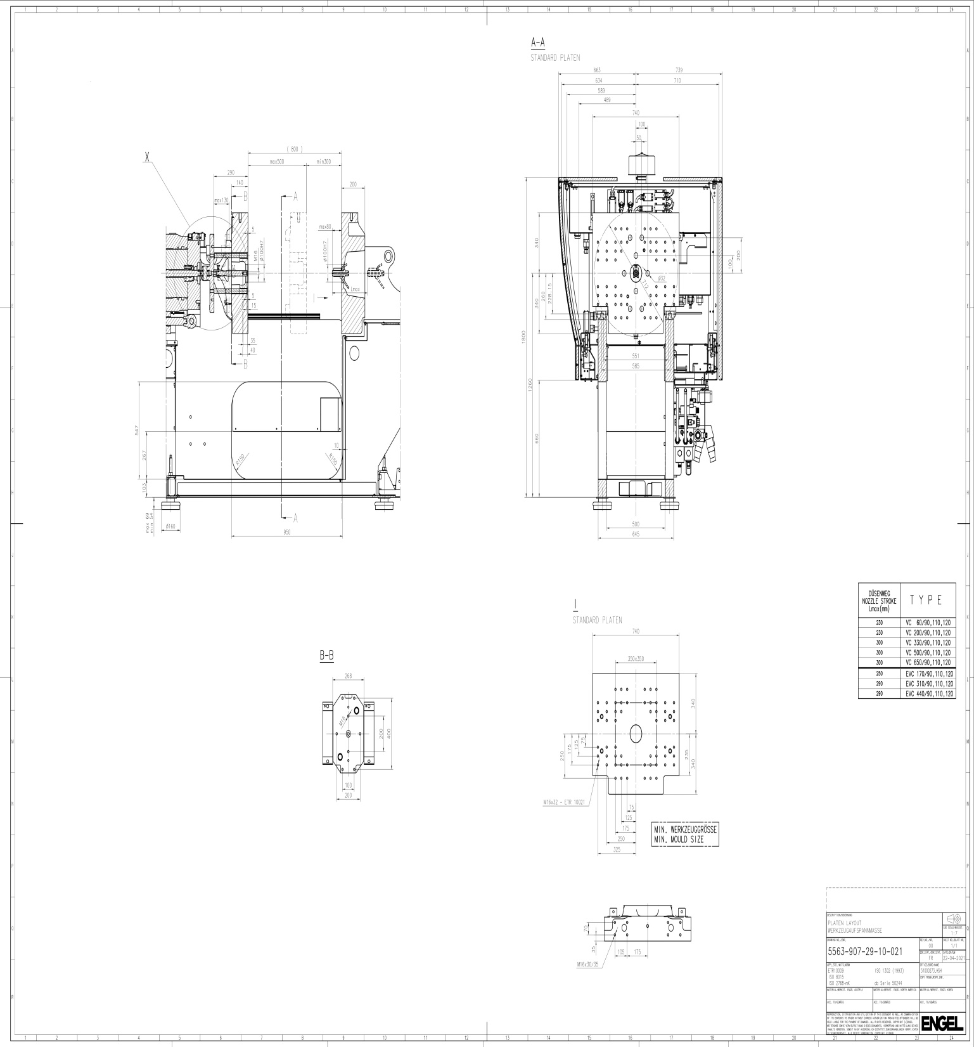
Annexure B
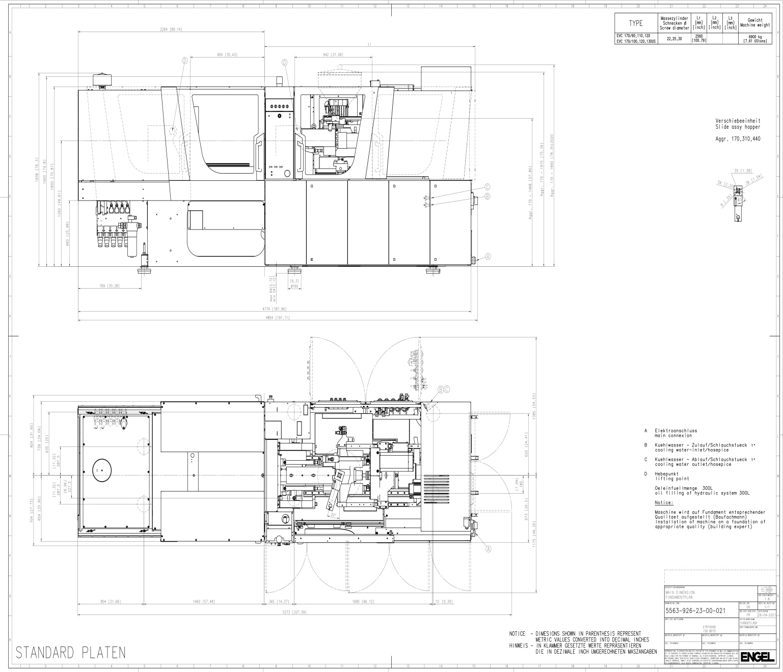

Schedule – B
Page 1 of 1

Minimum Eligibility Criteria

Questionnaire to be filled for Minimum Eligibility Criteria for qualifying in the Technical Bid

1. | Have executed similar type of hot runner mould for medical application. (Document shall be submitted to prove the experience) | YES/NO
2. | Do you have minimum three year experience in manufacturing and supply of product? (essential criteria for qualifying the Technical bid) | YES/NO
3. | EMD furnished or not | YES/NO
4. | Tender Fee furnished or not | YES/NO
5. | Have you furnished Declaration as per Schedule G | YES/NO
6. | What is your Annual Turnover for the last three years?
7. | Have you attached Udyog Aadhar registration certificate and bid Security declaration form, if you are MSME/SSI Bidder | YES/NO
8. | Do you agree to provide Security Deposit for an amount (3% of Order value) by DD or Bank guarantee from a National / Scheduled Bank before under taking the work, if awarded. | YES/NO

All the information provided herein is true & correct

PLACE: NAME AND SIGNATURE OF THE APPLICANT
DATE: (WITH OFFICE SEAL)

Schedule – C
Page 1 of 2
HLL LIFECARE LIMITED
(A Government of India Enterprise)
AKKULAM FACTORY, SREEKARIYAM P.O,
THIRUVANANTHAPURAM-695017

III. QUESTIONNAIRE

(General information of the supplier)

1. Name & Address of the supplier with :
(a) Telephone No.
(b) Fax No.
(c) E – mail Address
(d) Name of the contact person
(e) Whether proprietory / partnership / Limited company.
(f) Specify whether SSI / MSME unit
If Yes, pl specify if your unit is owned by :
SC/ST entrepreneur
(g) MSME Udyog Aadhar No.

2. How many years have you been in the :
business of manufacturing

3. What would be the minimum period :
required to deliver the mould from the date of
confirmed Purchase order?

4. Are you an existing supplier to HLL? (and if yes,
Since when……………….)

5. Have you been a supplier / manufacturer, :
if so details of the name, address,
quantity and values of orders received and executed during
last three years? (Attach separate sheet)

6. Have you executed similar type of fully hot :
runner mould for medical application. If yes
give details with proof.

Schedule – C
Page 2 of 2

7. Are you willing to accept HLL technical team :
site visit to evaluate the tool manufacturing
facility as part of technical bid qualification.

8. Have you attached the mould concept design :
drawing with the technical file (If it is not
attached, the tender is likely to be rejected)

9. Brief details of the machinery, instruments :
and technical staff
(attach separate sheet if required)

10. Name of major customers
(attach separate sheet if required)

11. What is your Annual Turn Over during the :
last 3 years?

12. What is your :- :
a) GST No
d) PAN No :
13. Name & Address of your Banker(s) :

14. Any other details :

All the information provided herein is true & correct.

PLACE:
NAME & SIGNATURE OF THE APPLICANT
DATE: (WITH OFFICE SEAL)

Schedule – D
Page 1 of 1

Annexure -IV
PROFORMA FOR PERFORMANCE STATEMENT
(for a period of last 3 years)
(ON THE LETTER HEAD OF THE COMPANY)

SL. No | Order Received from  (Name & Address of Purchaser) | Description  of Purchase Order received | Quantum of work | Attach performance certificate received from the purchaser

PLACE: NAME AND SIGNATURE OF THE BIDDER
DATE: (WITH OFFICE SEAL)

Schedule-E
Page 1 of 5
HLL LIFECARE LIMITED
(A Government of India Enterprise)
AKKULAM FACTORY, SREEKARIYAM P.O,
THIRUVANANTHAPURAM-695017

V. TERMS & CONDITIONS

1. The tender should be completed in all respects; incomplete tenders are liable to be rejected.
The bidder shall furnish, as part of his Bid, a Bid Security (EMD) for an amount of Rs.25,000/- and a tender fee of Rs.500 + GST (Rs.590/-). Each bid must be accompanied by EMD. Any Bid not accompanied by an acceptable Bid Security (EMD) shall be rejected as non-responsive. Tender fee (Non-refundable) and EMD as per the tender conditions shall be paid separately, thru RTGS/NEFT transfer or as DD in the following HLL A/c details:
Name of Bank: State Bank of India
A/c number: 30307559515
IFSC Code: SBIN0004350
Branch name: Commercial Branch, Thycaud, Thiruvananthapuram

Note: SSI/MSE units interested in availing exemption from payment of Tender Fee & EMD should submit a valid copy of their MSME /Udyog Aadhaar registration certificate.
NOTE: MSME bidders have to sign a Bid Security Declaration form accepting that if they with draw or modify the bids during period of validity etc , they will be suspended for the time specified in tender documents

2. SUPPLY:
The successful tenderer will have to supply the mould within the stipulated delivery time mentioned in the Purchase order .
3. TERMINATION OF CONTRACTS:
In case, after issue of a firm order, the successful tenderer fails to supply the item as per the specified quality and the required quantity according to the Delivery Schedule as given in the Supply Order, and even fails to complete the supply within the extended period if any given in writing by HLL Lifecare Limited, Thiruvananthapuram, it will be within HLL’s full rights to terminate the contract.
HLL Lifecare Limited, will have the full right to reject any or all the tenders without assigning any reason whatsoever. The HLL Lifecare Limited, also reserves the right to award the contract with more than one contractor.

Schedule-E
Page 2 of 5

4. PRICE:
Price: The tenderer has to quote the rate for supply of the item as per unit as given in the tender. Statutory levies if any such as GST etc. should be shown separately. Rates quoted should be strictly as per HLL’s format.
Price variation: Rate quoted shall be firm and valid for a period of one year from the date of opening of the tender. The benefit of reduction of statutory levies should be passed on to the purchaser.
5. RELEASE OF PURCHASE ORDER:
The purchaser may consider placement of a purchase order for commercial supplies on those bidder(s), whose offers have been found technically, commercially and financially acceptable.
During the period of contract, if so desired by the purchaser, the supplier (s) premises shall be visited by the purchaser for inspection/evaluation.
Security deposit: On awarding the contract, the tenderer shall furnish Security Deposit by either Cash Deposit or Bank Guaranty for a value of 3% of Order value subject to a maximum of Rs.2,00,000/- which will be returned without interest on completion of contract period. This Security Deposit shall be forfeited in case the tenderer withdraws from the contract once it is awarded or fails in completing the work in time as required by the Company or in case any loss or damage is caused to the Company by the contractor or by his/her/its workers or on breach of any of the conditions of the contract. Loss or damage caused to the Company at the instance of the contract shall be recovered from the Security Deposit in proportionate to the loss or damage sustained by the Company and the decision on the amount of compensation for the loss or damage shall be at the discretion of the company. The Company shall also have the right to recover such loss or damage from the movable or immovable properties of the contractor and his heirs and legal representatives if the loss or damage caused is in excess of Security Deposit.
6. PAYMENT:
- 60% of the order value against successful mould trial and qualification of components at supplier’s site.
- 30% of order value against supply, qualification and acceptance of mould at HLL AFT.
- 10% will be retained as Retention Money which shall be paid after one year from the date of successful SAT OR shall be paid against a performance bank guarantee for an amount equivalent to 10% of order value from a scheduled bank with validity of one year from date of acceptance of the mould.
Normally the Purchaser will not entertain any advance payment. However, the bidder can indicate advance payment in the payment terms, if required. Moreover such advance payment, will be released against submission of a Bank guarantee, on a specific format

Schedule-E
Page 3 of 5

given by the supplier, from a nationalized/scheduled bank for like amount valid up to the supply of equipment at purchaser’s site.

7. Warranty: One year from the date of acceptance of the mould.
8. PURCHASER’S RIGHT TO ACCEPT ANY BID AND TO REJECT ANY OR ALL BIDS
The Purchaser reserves the right to accept or reject any bid, and to annul the bidding process and reject all bids, at any time prior to award of contract without assigning any reason whatsoever and without thereby incurring any liability to the affected bidder or bidders on the grounds of purchaser’s action.
9. Mould detailed drawing to be handed over to HLL (Soft copy & Hard copy) along with Molud.
10. TRAINING
The bidder shall provide necessary training for operation & maintenance staffs of the purchaser at free of cost.
11. Despatch documents like delivery note/challan, packing list and invoice should be intimated immediately with the LR No/Shipping Bill No/Air way Bill No.
12. The jurisdiction of any disputes, suits and proceedings arising out of this tender shall be only in the courts of Thiruvananthapuram, Kerala State, India
13. “Any disputes or difference whatsoever arising between the parties out of or relating to the construction, meaning and operation or effect of this contract or the breach thereof shall be settled by arbitration in accordance with the rules of arbitration of the Indian Council of Arbitration and the award made in pursuance thereof shall be binding on the parties” in case the matter is referred for arbitration.
14. The decision of HLL will be final and no correspondence on this shall be entertained.
15. There will not be any post tender negotiation except with the first lowest responsive bidder
16. The jurisdiction of any disputes, suits and proceedings arising out of this tender shall be only in the courts of Thiruvananthapuram, Kerala State, India.
17. Penalty clause: If the supplier fails to supply within the specified period, the Penalty shall be at the rate of 0.5% per week subject to a maximum of 7.5% of the total contract value for the delay beyond the agreed period. Once the maximum is reached, the Purchaser may consider termination of the Contract at cost of supplier.
18. This tender is liable to be cancelled at any time at the discretion of the Unit Chief of Akkulam Factory, Thiruvananthapuram without assigning any reason or giving any notice and his decision will be final and binding on all concerned parties.

Schedule-E
Page 4 of 5
19. TERMINATION BY DEFAULT
19.1 In case the Supplier fails to deliver any or all of the goods within the period specified in the LOI/PO or extension thereof or the Supplier fails to perform any other obligation(s) under the contract, the Purchaser may, without prejudice to any other remedy for breach of contract, by written notice of default sent to the supplier, terminate the Contract in whole or part;
19.2 In the event the such termination, in whole or in part, the Purchaser may procure the Goods or Services similar to those undelivered, and the Supplier shall be liable to the Purchaser for any excess costs for such similar Goods/Services.
20. FORCE MAJEURE

20.1 For purposes of this Clause “Force Majeure” means an event beyond the control of the Supplier and not involving the Supplier’s fault or negligence and not foreseeable. Such events may include, but are not limited to, acts of the Purchaser either in its sovereign or contractual capacity, as or revolutions, fires, floods, epidemics, quarantine restrictions and freight embargoes.
20.2 If a Force Majeure situation arises, the Supplier shall promptly notify the Purchaser in writing of such conditions and the cause thereof. Unless otherwise directed by the Purchaser in writing, the Supplier shall continue to perform its obligations under the Contract as far as is reasonably practical, and shall seek all reasonable alternative means for performance not prevented by the force majeure event.
21. TERMINATION FOR INSOLVENCY
The Purchaser may at any time terminate the Contract by giving written notice to the Supplier, if the Supplier becomes bankrupt or otherwise insolvent. In this event, termination will be without compensation to the Supplier, provided that such termination will not prejudice or affect any right of action or remedy which has accrued or will accrue thereafter to the Purchaser.
22. RESOLUTION OF DISPUTES

22.1 The Purchaser and the supplier shall make every effort to resolve amicably by direct informal negotiation any disagreement or dispute arising between them under or in connection with the Contract.

22.2 If, after thirty (30) days from the commencement of such informal negotiations, the Purchaser and the Supplier have been unable to resolve amicably a Contract dispute, either party may require that the dispute be referred for resolution to the formal mechanisms specified in the Special Conditions of Contract. These mechanisms may include, but or not limited to, conciliation mediated by a third Party, adjudication in an agreed national forum, and national arbitration.
38.3 The jurisdiction of any disputes, suits and proceeding arising out of the tender shall be only in the court of Thiruvananthapuram.

Schedule-E
Page 5 of 5

23. GOVERNING LANGUAGE

The contract shall be written in English language. English language version of the Contract shall govern its interpretation. All correspondence and documents pertaining to the Contract which are exchanged by the parties shall be written in the same language.
24. APPLICABLE LAW

The Contract shall be interpreted in accordance with the India Law.

Joint General Manager (Materials)

SCHEDULE – F
Page 1 of 1

HLL LIFECARE LIMITED
(A Government of India Enterprise)
AKKULAM FACTORY, SREEKARIYAM P.O,
THIRUVANANTHAPURAM-695017

VI. INDEMINITY CLAUSE:
If the supplier fails to execute the order within the time prescribed for the delivery of goods ordered or violates or infringes the existing rates as agreed to as mentioned in the supply order, the supplier shall and will indemnify the company against all loses or damages whatsoever to be incurred or sustained including the legal cost or expenses incurred by the company by reason of non-delivery of equipment at agreed quantity and rate with in the time specified in the supply order. The company will initiate legal action if the supplier fails to execute the supply order as per the schedule in the supply order for the actual loss suffered. Responsiveness of the Bid shall be at the discretion of HLL.
The supplier shall have no right to change the conditions stipulated in the supply order.
Bid pronounced Non Responsive by HLL shall be summarily rejected.
The decision of HLL will be final and no correspondence of this shall be entertained.
We have read and understood the above conditions and agree to abide by the same.

PLACE: NAME AND SIGNATURE OF THE APPLICANT
DATE: (WITH OFFICE SEAL)

SCHEDULE - G
Page 1 of 1

HLL LIFECARE LIMITED
(A Government of India Enterprise)
AKKULAM FACTORY, SREEKARIYAM P.O,
THIRUVANANTHAPURAM-695017

VII. DECLARATION

We confirm having read and understood all the specifications, instructions, forms, terms and conditions and other requirements of the above tender (both expressed and implied) in full and that we agree to abide by all without any deviation.

SEAL OF THE APPLICANT SIGNATURE

NAME AND ADDRESS OF APPLICANT

SCHEDULE – H Page 1of 1
BID SECURITY DECLARATION FORM

Date: ___________________ Tender No. _________________

To (insert complete name and address of the purchaser)

I/We. The undersigned, declare that:
I/We understand that, according to your conditions, bids must be supported by a Bid
Securing Declaration.

I/We accept that I/We may be disqualified from bidding for any contract with you for a period of one year from the date of notification if I am /We are in a breach of any obligation under the bid conditions, because I/We
a) have withdrawn/modified/amended, impairs or derogates from the tender, my/our Bid during the period of bid validity specified in the form of Bid; or
b) having been notified of the acceptance of our Bid by the purchaser during
the period of bid validity
(i) fail or reuse to execute the contract, if required, or
(ii) fail or refuse to furnish the Performance Security, in accordance with
the Instructions to Bidders.

I/We understand this Bid Securing Declaration shall cease to be valid if I am/we are not the successful Bidder, upon the earlier of (i) the receipt of your notification of the name of the successful Bidder; or (ii) thirty days after the expiration of the validity of my/our Bid.
Signed: (insert signature of person whose name and capacity are shown)
in the capacity of (insert legal capacity of person signing the Bid Securing
Declaration)
Name: (insert complete name of person signing he Bid Securing Declaration)
Duly authorized to sign the bid for an on behalf of (insert complete name of Bidder)
Dated on _____________ day of ___________________ (insert date of signing)

HLL LIFECARE LIMITED
(A Government of India Enterprise)
AKKULAM FACTORY, SREEKARIYAM P.O,

THIRUVANANTHAPURAM-695017
Email: materialsaft@lifecarehll.com
Website: www.lifecarehll.com
PH: +91 471 2442641, 2445930
FAX: +91 471 2445935

INVITATION FOR BID

(PRICE BID)

FOR

Design, Fabrication, Supply & Qualification of
Eight Cavity automatic Hot Runner Tee Mould

Quantity: 1 Number

AT

AKKULAM FACTORY
THIRUVANANTHAPURAM – 695 017

SCHEDULE - I
Page 1 of 1
HLL LIFECARE LIMITED
(A Government of India Enterprise)
AKKULAM FACTORY, SREEKARIYAM P.O,
THIRUVANANTHAPURAM-695017

VIII. PRICE BID

NAME OF THE ITEM: Design, Fabrication, Supply & Qualification of :

Eight Cavity automatic Hot Runner Tee Mould

Sl. No: | Particulars | Unit | Qty | Rate (Rs.) | Amount (Rs.)
1. | Design, Fabrication, Supply & Qualification of Eight Cavity automatic Hot Runner Tee Mould | No | 1
2 | Any other expenses
Total Amount (Rs.)
GST (Specify HSN Code:……….……………)
Grand Total (Rs.)

Any other Remark (s) :

Certified that the rate quoted will hold good for 90 days, during which period no upward revision will be asked for.

NAME OF TENDERER: ______________________________

Place: ADDRESS AND SIGNATURE OF THE TENDERER Date: (WITH OFFICE SEAL)

